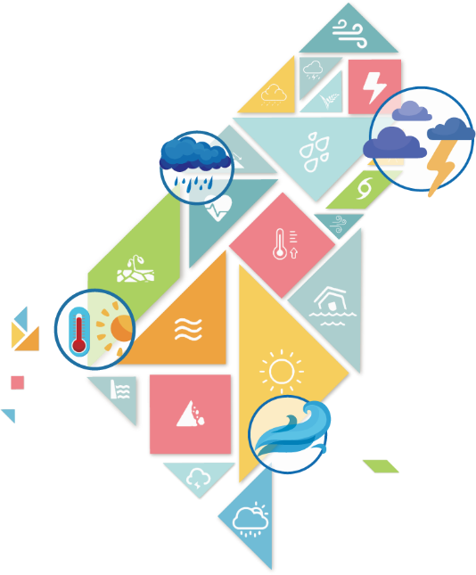
2019氣候變遷國際工作坊
TCCIP International Workshop on Climate Change
- A better future with better climate change services

主辦單位：國家災害防救科技中心(NCDR)
補助單位：科技部自然科學及永續研究發展司
國外參與單位：德國氣候服務中心(GERICS)、日本文部科學省氣候變遷整合研究計畫(TOUGOU)以及日本國立環境研究院氣候變遷調適中心(CCCA)
簡介
面對氣候變遷威脅以及不確定性，如何提升科學的分析與應用、方法與工具的發展，來支持國家、部會與地方政府因應未來氣候變遷所造成的衝擊，乃氣候變遷服務的重要工作，也是氣候變遷科學研究落實應用的具體貢獻。
為此，科技部自然科學及永續研究發展司補助的「臺灣氣候變遷推估資訊與調適知識平台計畫」（TCCIP）將於10月22至24日在臺大霖澤館國際會議廳舉辦「2019氣候變遷國際工作坊」(2019 International Workshop on Climate Change, 2019 IWCC)，以「A Better Future with Better Climate Change Services」為主題，並由兩位國際級專家進行主題演講：分別是德國氣候服務中心(GERICS)主任Prof. Dr. Daniela Jacob，以及在日本文部科學省氣候變遷整合研究計畫TOUGOU中，統籌「衝擊預測與評估分組」的京都大學防災研究所中北英一教授(Prof. Dr. Eiichi Nakakita)。
此外，本次工作坊中，特別邀請長期與TCCIP合作推動氣候變遷相關研究的德國氣候服務中心(GERICS)、日本文部科學省氣候變遷整合研究計畫(TOUGOU)以及日本國立環境研究院氣候變遷調適中心(CCCA)的12名專家學者，以及9名TCCIP團隊成員，針對氣候數據與分析(Climate Data and Analysis)、氣候變遷衝擊與調適(Climate Change Impact and Adaptation)和創新氣候服務(Innovative Services)三大主題進行21場簡報。同時，會場將展出20幅TCCIP研究成果海報，並提供與會者和研究人員互動的機會，讓知識分享與國際交流能更為活絡。

大會細部議程 (全程以英文進行)
Day 1 (10/22, Tuesday)
Time | Schedule | Presenter
9:00-9:30 | Opening Ceremony/Group Photo
9:30-10:00 | Keynote Address：“Perspectives on climate change impact assessment and adaptation from TOUGOU-D” | Prof. Dr. Eiichi Nakakita/ Representative of TOUGOU-D
10:00-10:20 | Coffee Break
Session 1: Climate Data and Analysis-1
10:20-10:40 | TOUGOU-C: Integrated Climate Change Projection | Dr. Akio Kitoh (TOUGOU-C)
10:45-11:05 | Tropical cyclone translation speed in a warmed climate | Dr. Munehiko Yamaguchi (TOUGOU-C)
11:10-11:30 | Global warming projection using HIRAM for the mid and end of 21st century. | Dr. Huang-Hsiung Hsu (TCCIP)
11:35-11:55 | Statistical downscaling over Taiwan | Dr. Cheng-Ta Chen (TCCIP)
12:00-13:00 | Lunch
Session 2: Climate Impact and Adaptation-1
13:00-13:20 | Statistical downscaling of daily data in hydrological analysis and its application | Dr. Ke-Sheng Cheng  (TCCIP)
13:25-13:45 | Applied Statistical Downscaling Data on Risk Map of Flood Disasters | Dr. Yun-Ju Chen (TCCIP)
Session 3: Innovative Services-1
13:50-14:10 | From data to climate change services | Dr. Yu-Shiang Tung (TCCIP)
14:15-14:35 | Innovation in Climate Services Provision and Climate Adaptation in Cities | Ms. Jo-Ting Huang-Lachmann (GERICS)
14:40-15:00 | Coffee Break
15:00-16:15 | Poster Session
16:20-17:00 | Keynote Address (Live-Streaming from Germany): “The Quality and Future of Climate Services” | Prof. Dr. Daniela Jacob/  Director of GERICS
18:00 | Reception

Day 2 (10/23, Wednesday)
Time | Schedule | Presenter
Session 4: Climate Data and Analysis-2
9:00-9:20 | Regional dependence of extreme precipitation and its future projection in Japan | Dr. Takafumi Miyasaka (TOUGOU-C)
9:25-9:45 | Future Changes in a Typhoon in the Midlatitude | Dr. Sachie Kanada (TOUGOU-C)
9:50-10:10 | Challenges of Regional Climate Modelling | Dr. Claas Teichmann (GERICS)
10:15-10:35 | Future projection of Typhoons near Taiwan | Dr. Chao-Tzuen Cheng (TCCIP)
10:40-11:00 | Coffee Break
Session 5: Climate Impact and Adaptation-2
11:00-11:20 | Ensemble Inundation impacts assessment under RCP8.5 Scenario. | Dr. Keh-Chia Yeh (TCCIP)
11:20-11:40 | Landslide impact and uncertainty analysis under climate change scenario | Dr. Hshin-Chi Li (TCCIP)
12:00-13:00 | Lunch
Session 6: Climate Impact and Adaptation-3
13:00-13:20 | Flood risk assessment under a changing climate using a large ensemble climate data | Dr. Tomohiro Tanaka (TOUGOU-D)
13:25-13:45 | The impact assessment of localized heavy rainfall in Japan under global warming from the multiple spatial scale. | Ms. Yukari Osakada
13:50-14:10 | The role of bias correction for the projection of hydrological extremes using large ensemble climate simulations | Dr. Satoshi Watanabe (TOUGOU-D)
14:15-14:35 | Future dispersal and connectivity of world’s northernmost coral reefs. | Dr. Shintaro Takao (TOUGOU-D)
14:40-15:00 | Coffee Break
15:00-16:15 | Poster Session
Day 2 (10/23, Wednesday)
Session 7: Innovative Services-2
16:20-16:40 | Center for Climate Change Adaptation: the national hub for climate change adaptation | Dr. Yoshifumi Masago
16:40-17:00 | Developing Climate Change Integrated Service Platform under Design Thinking | Dr. Tzu-Ming Liu (TCCIP)

Day 3 (10/24, Thursday)-Invited Only
Time | Schedule | Presenter
8:00-9:00 | Commute to Keelung (Transportation will be arranged)
9:30-10:30 | Climate service (Practice) | Guided by Dr. Costa from GERICS
10:30-10:45 | Coffee Break
10:45-12:00 | Climate service (Practice) | Guided by Dr. Costa from GERICS
12:00-13:00 | Lunch
13:00-14:50 | Close Meeting
15:00-18:00 | Scheduled visits
18:00-19:30 | Dinner
19:45-21:00 | Return to Taipei (Transportation will be arranged)

講者名單
名字 | 單位/職稱
Prof. Dr. Daniela Jacobs | Climate Service Center Germany (GERICS)/ Director
Prof. Dr. Eiichi Nakakita  (中北英一) | TOUGOU-D/ Representative
Dr. Akio Kitoh  (鬼頭昭雄) | Office of Climate and Environmental Research Promotion, Japan Meteorological Business Support Center/ Director
Dr. Takafumi Miyasaka  (宮坂貴文) | Office of Climate and Environmental Research Promotion, Japan Meteorological Business Support Center/ Researcher
Dr. Munehiko Yamaguchi  (山口宗彥) | Japan Meteorological Business Support Center (JMBSC)/Researcher
Dr. Sachie Kanada  (金田幸惠) | Nagoya University Center for Integrated Data Science/ Designated Assistant Professor
Dr. Satoshi Watanabe  (渡部哲史) | School of Engineering, The University of Tokyo
Dr. Tomohiro Tanaka  (田中智大) | Graduate School of Engineering, Kyoto University
Dr. Shintaro Takao  (高尾信太郎) | National Institute for Environmental Studies
Ms. Yukari Osakada  (小板田 ゆかり) | Graduate School of Engineering, Kyoto University
Dr. Yoshifumi Masago  (真砂佳史) | Center for Climate Change Adaptation, National Institute for Environmental Studies/ Senior Researcher
Dr. Claas Teichmann | The Climate Service Center Germany (GERICS) / Scientist
Dr. María Máñez Costa | The Climate Service Center Germany (GERICS) / Scientist
Jo-Ting Huang-Lachmann  (黃若亭) | The Climate Service Center Germany (GERICS) / Scientist
Dr. Huang-Hsiung Hsu  (許晃雄) | Research Center for Environmental Changes, Academia Sinica/ Deputy Director and Research Fellow
Dr. Cheng-Ta Chen  (陳正達) | Department of Earth Sciences and Institute of Marine Environmental Science and Technology, National Taiwan Normal University / Joint Professor
Dr. Ke-Sheng Cheng  (鄭克聲) | Department of Bioenvironmental Systems Engineering, National Taiwan University / Professor
Dr. Yeh Ke-Chia  (葉克家) | Department of Civil Engineering, National Chiao-Tung University / Professor
Dr. Yun Ju Chen  (陳韻如) | National Science and Technology Center for Disaster Reduction / Associate Researcher
Dr. Yu-Shiang Tung  (童裕翔) | National Science and Technology Center for Disaster Reduction / Assistant Researcher
Dr. Chao-Tzuen Cheng  (鄭兆尊) | National Science and Technology Center for Disaster Reduction / Associate Researcher
Dr. Hsin-Chi Li  (李欣輯) | National Science and Technology Center for Disaster Reduction / Researcher
Dr. Tzu-Ming Liu  (劉子明) | National Science and Technology Center for Disaster Reduction / Assistant Researcher

